CAPSTONE PROJECT:

GENRE BASED OTT SUBSCRIPTION

BY,
M. HARJITH
JAVA FULL STACK (FACEPREP)
43731073
B.E CSE - AI

INTRODUCTION:

- The project aims to design and develop an OTT (Over-The-Top) Streaming Platform that automates the process of content delivery, user subscription management, and role-based access control.

- It provides a user-friendly platform where users can browse and access movies, series, news, and sports content, allowing them to select subscription plans based on preferred genres and manage their viewing experience efficiently.

- The system helps users discover content according to their interests while enabling secure authentication and subscription-based content access.

- The platform includes multiple modules such as Admin Module, User Module, Subscription Module, Content Management Module, and Payment Module, ensuring smooth operation, monitoring, and scalability of the system.

ABSTRACT

This project involves the design and development of a web-based Over-The-Top (OTT) streaming platform implemented using Spring Boot, Thymeleaf, and MySQL. The application provides secure user registration and login functionality with password encryption using BCrypt and session management for authenticated access. Users can browse content categorized into Movies, Series, News, and Sports through a visually structured dashboard inspired by modern streaming platforms. A subscription system is implemented where users select preferred genres using checkboxes, dynamically determine the subscription cost, complete a simulated payment process, and unlock premium content across the platform. Subscription status and selected genres are stored and managed in the database and reflected consistently across all content pages. The system also includes a separate Admin module with an independent login interface, allowing administrative access distinct from regular users. Role-based access is handled at the application level to differentiate user and admin functionality. The backend follows the MVC architecture, with Spring Data JPA managing database operations and MySQL storing user credentials, roles, subscription status, and genre preferences. All described features are fully implemented and operational, demonstrating the practical application of secure authentication, role management, subscription handling, and dynamic content control within a real-world OTT platform.

CLIENT REQUIREMENT

The client requires an OTT (Over-The-Top) Streaming Platform where users can securely register, log in, and access digital content such as Movies, Series, News, and Sports. The platform should allow users to browse content through a centralized dashboard and unlock premium content via a subscription-based model. The system must support genre-based subscriptions where users can select preferred genres, complete a mock payment process, and gain access accordingly. An Admin module is required with a separate login interface to manage platform operations and monitor users. The platform should visually resemble modern OTT applications and provide smooth navigation between content categories.

OBJECTIVES:

- Admin should be able to log in through a separate admin login page.
- Admin should be able to monitor subscription status.
- Users should be able to register and log in securely using encrypted passwords.
- Users should be able to browse Movies, Series, News, and Sports.
- Users should be able to subscribe by selecting multiple genres.
- Subscription cost should change dynamically based on selected genres.
- Premium content should be locked or unlocked based on subscription status.
- Subscription status should reflect across the dashboard.

TECHNICAL REQUIREMENTS:
- Proper Login and Registration functionality using Spring Boot.
- Secure password handling using BCrypt encryption.
- Session-based authentication for user login management.
- Role-based access handling for User and Admin modules.
- Proper user input validation during registration and login.
- Subscription handling with database persistence.
- MVC architecture implementation for clean separation of concerns.
- Dynamic UI rendering using Thymeleaf templates.

TECHNOLOGIES USED:
- Framework: Spring Boot (Java Framework)
- Programming Language: Java 21
- Build Tool: Maven
- IDE: Spring Tool Suite (STS / Eclipse)
- Server: Embedded Apache Tomcat
- Backend Technologies: Spring MVC, Spring Data JPA (Hibernate)
- Security: BCrypt Password Encryption
- Frontend: Thymeleaf, HTML, CSS
- Database: MySQL
- Architecture: MVC (Model-View-Controller)

SYSTEM REQUIREMENTS:
SOFTWARE REQUIREMENTS:
- Back End: Spring Boot Framework, Spring MVC, Spring Data JPA (Hibernate)
- Database Server: MySQL Server 8.0 Community Edition
- Web Server: Embedded Apache Tomcat
- IDE: Spring Tool Suite (STS) / Eclipse
- Front End: HTML, CSS, Thymeleaf
- Browser: Google Chrome
- Build Tool: Maven
- Security: BCrypt Password Encryption

TECHNOLOGY STACK:
FRONTEND TECHNOLOGIES:
Technology: HTML5
Version: N/A
Description: Used to structure the web pages such as login, dashboard, subscription, and admin pages.

Technology: CSS3
Version: N/A
Description: Used for styling and layout of the UI, including flexbox-based layouts inspired by OTT platforms.

Technology: Thymeleaf
Version: 3.x
Description: Server-side template engine used to render dynamic data from Spring Boot into HTML pages.
Technology: JavaScript
Version: ES6
Description: Used for client-side interactions such as genre selection, price calculation, and navigation.

Technology: Google Chrome
Version: Latest
Description: Browser used for testing and accessing the application.

BACKEND TECHNOLOGIES:

Technology: Java
Version: 21
Description: Core backend programming language used to implement business logic and application flow.

Technology: Spring Boot
Version: 4.0.0
Description: Main framework used to develop and run the backend application with embedded server support.

Technology: Spring MVC
Version: 7.x
Description: Handles HTTP requests, routing, controllers, and view resolution.

Technology: Spring Data JPA
Version: 4.0.0
Description: Simplifies database access and CRUD operations using repositories.

Technology: Hibernate
Version: 7.1.8
Description: ORM framework used for mapping Java entities to database tables.

Technology: Spring Security
Version: N/A
Description: Used for authentication, role-based access control, and password encryption.

Technology: BCrypt Password Encoder
Version: N/A
Description: Used to securely hash and validate user and admin passwords.

Technology: Apache Tomcat
Version: 11.x
Description: Embedded web server used to deploy and run the application

DATABASE TECHNOLOGIES:
Technology: MySQL
Version: 8.0 CE
Description: Relational database used to store users, roles, subscriptions, genres, and application data.

Technology: JDBC
Version: N/A
Description: Used internally by Spring Boot for database connectivity.

Technology: HikariCP
Version: Default
Description: High-performance connection pool for efficient database access.
Build tools:

Tool: Maven
Version: 3.x
Description: Dependency management and build automation tool.

Tool: Spring Tool Suite (STS)
Version: 4.x
Description: IDE used to develop, debug, and run the Spring Boot application.

Tool: MySQL Workbench
Version: N/A
Description: Used for managing and monitoring the database.

SECURITY ENFORCEMENT:

Technology: Spring Security
Description: Used to implement authentication and authorization for the application.

Technology: BCrypt Password Encoding
Description: User and admin passwords are securely encrypted using BCrypt before storing in the database.

Concept: Role-Based Access Control
Description: Users are assigned roles such as USER and ADMIN to control access to dashboards and features.

Concept: Secure Login & Registration
Description: Login and registration functionality validates user credentials before granting access.
Process: Admin Authentication
Description: Separate admin login ensures only authorized administrators can access admin functionalities.

Process: Data Validation
Description: User input is validated to prevent invalid or malicious data from being processed.

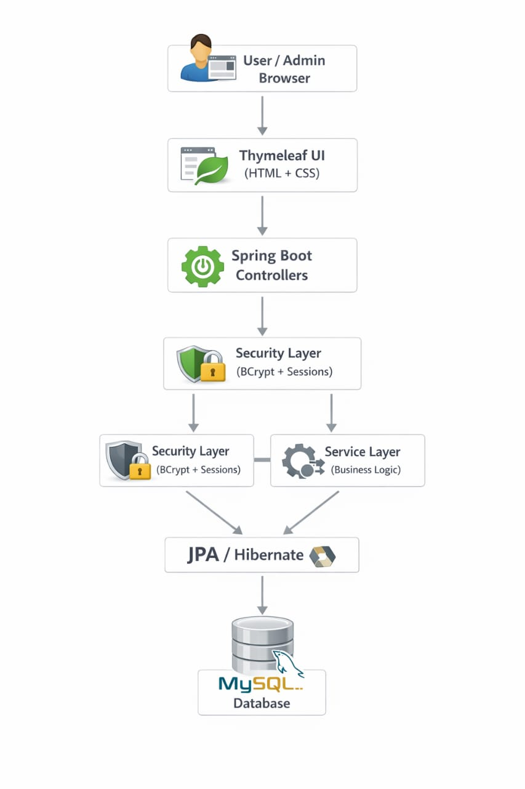
SYSTEM ARCHITECTURE DIAGRAM:

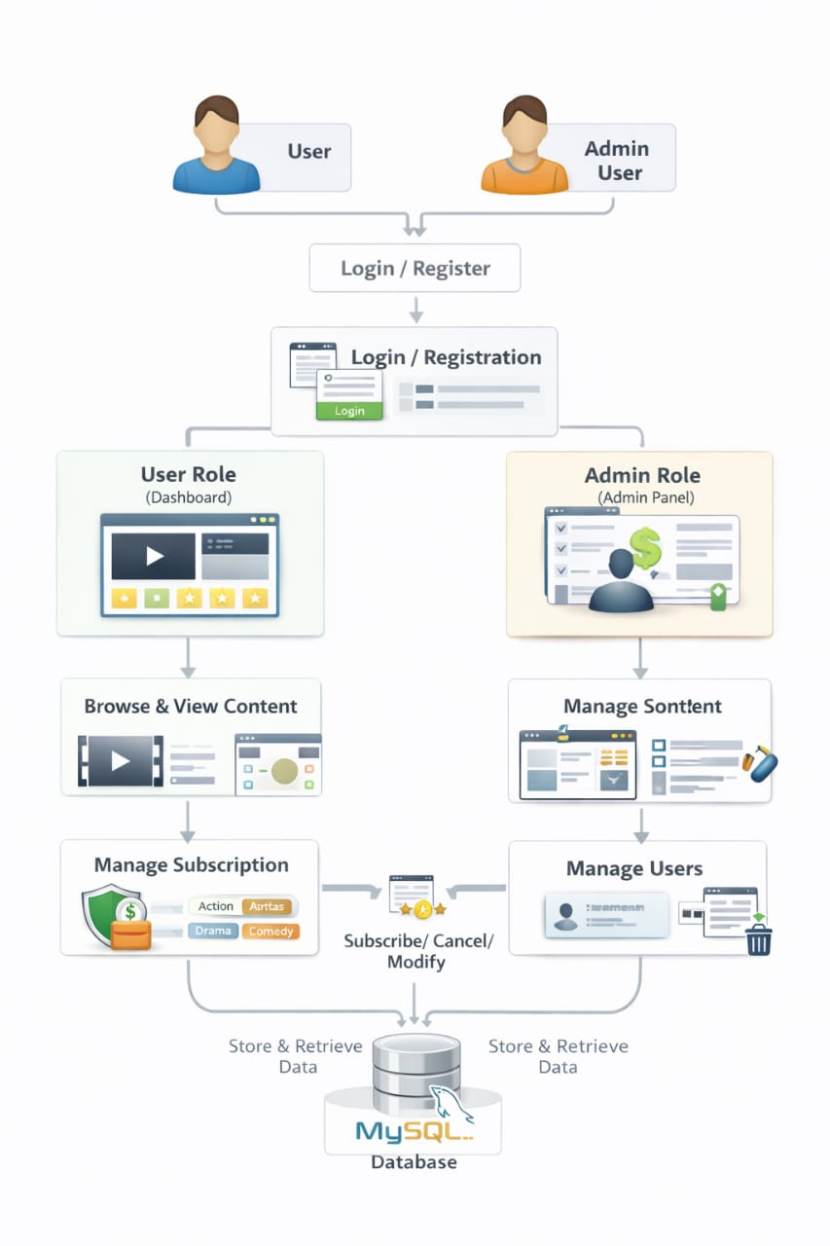
WORKFLOW:

PROJECT OUTPUT (DATABASE):

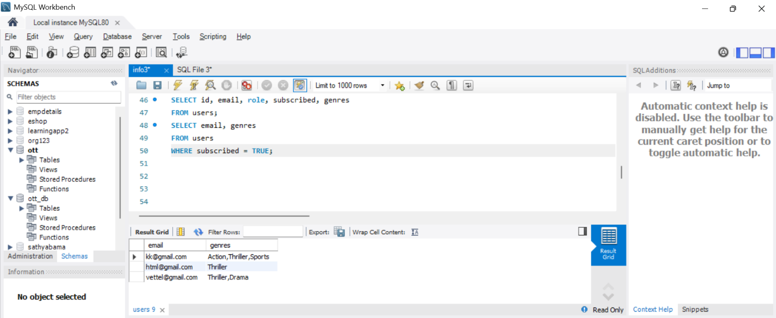
Subscribed users and their genre based subscriptions:

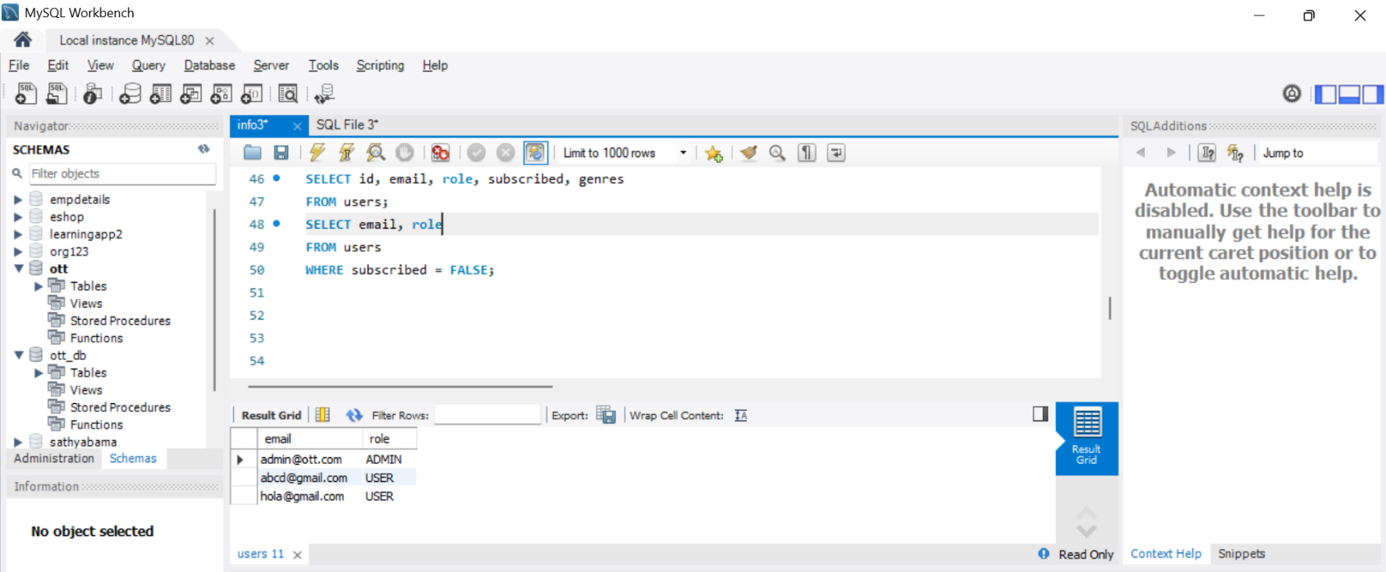
Unsubscribed users:
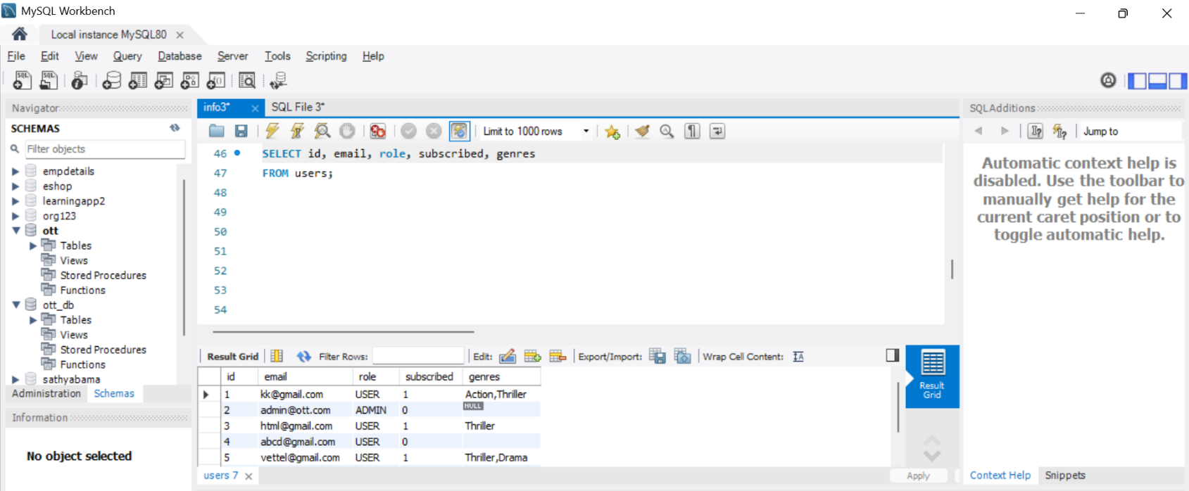
User table along with roles:

PROJECT OUTPUT:
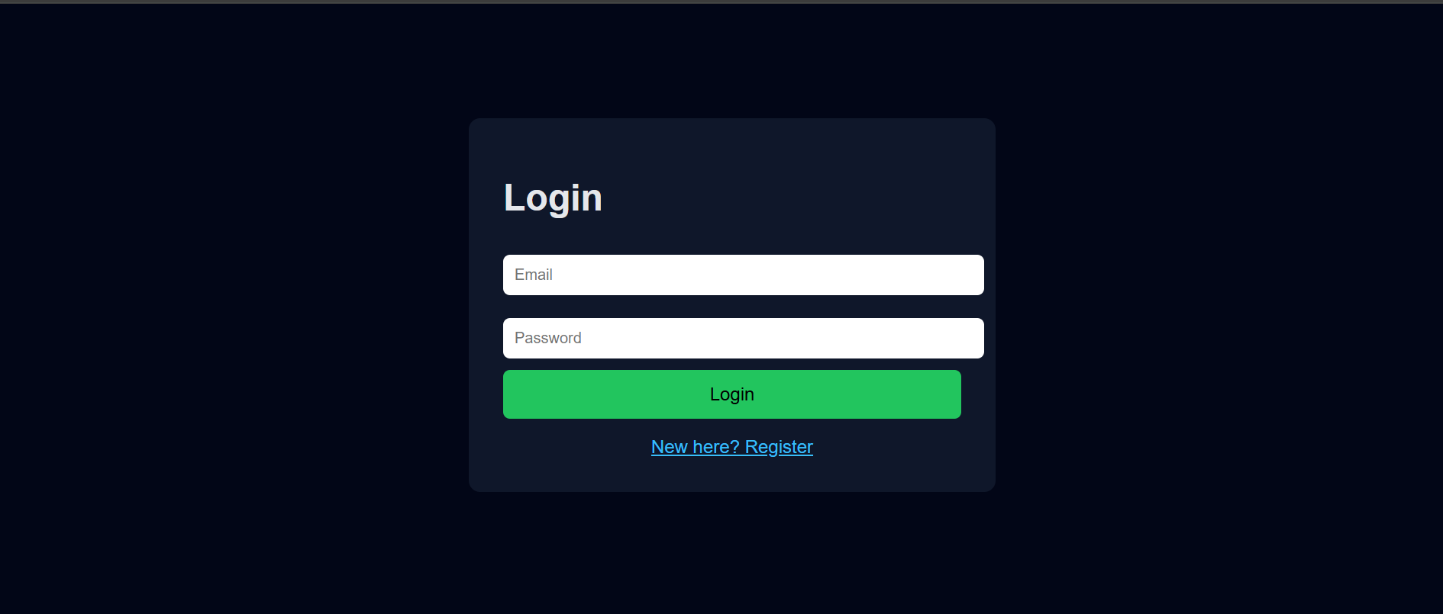
LOGIN PAGE:

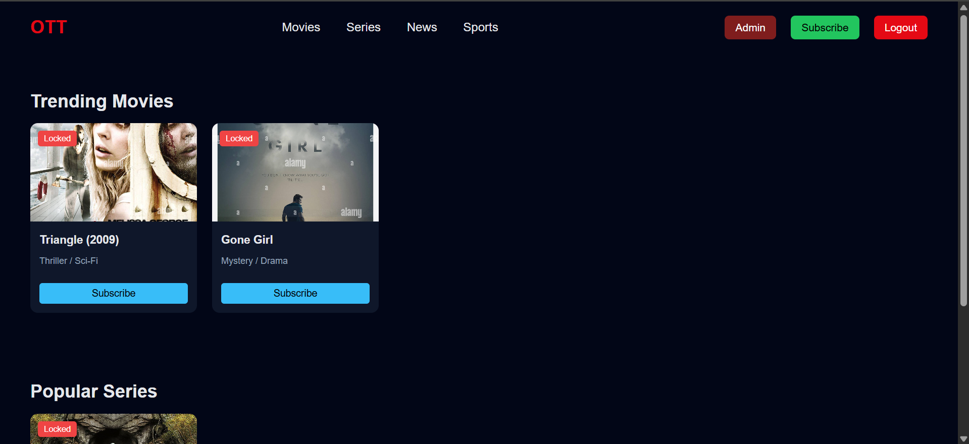
DASHBOARD (LOCKED CONTENT):

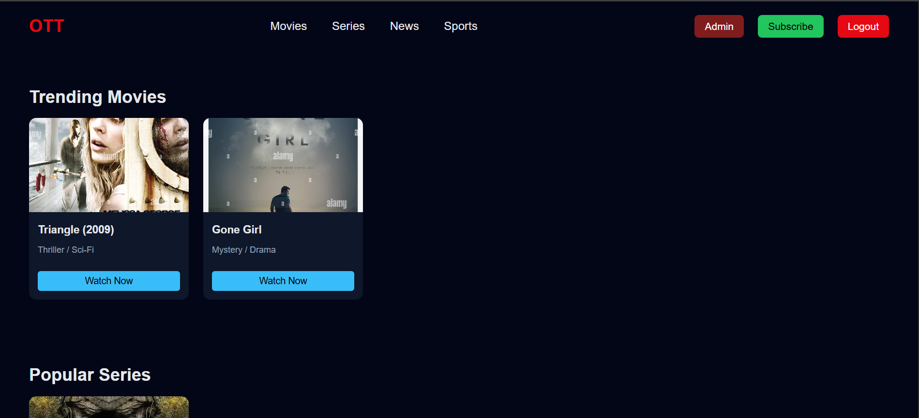
DASHBOARD (UNLOCKED CONTENT):

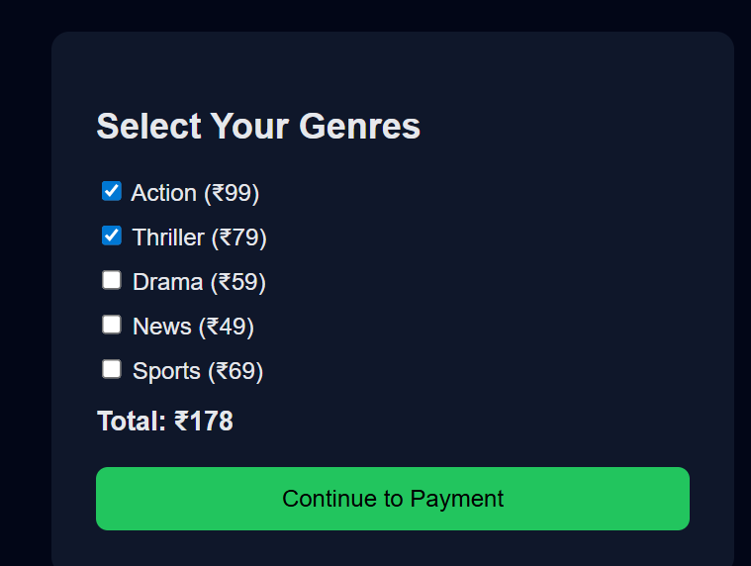
GENRE SELECTION WIZARD:

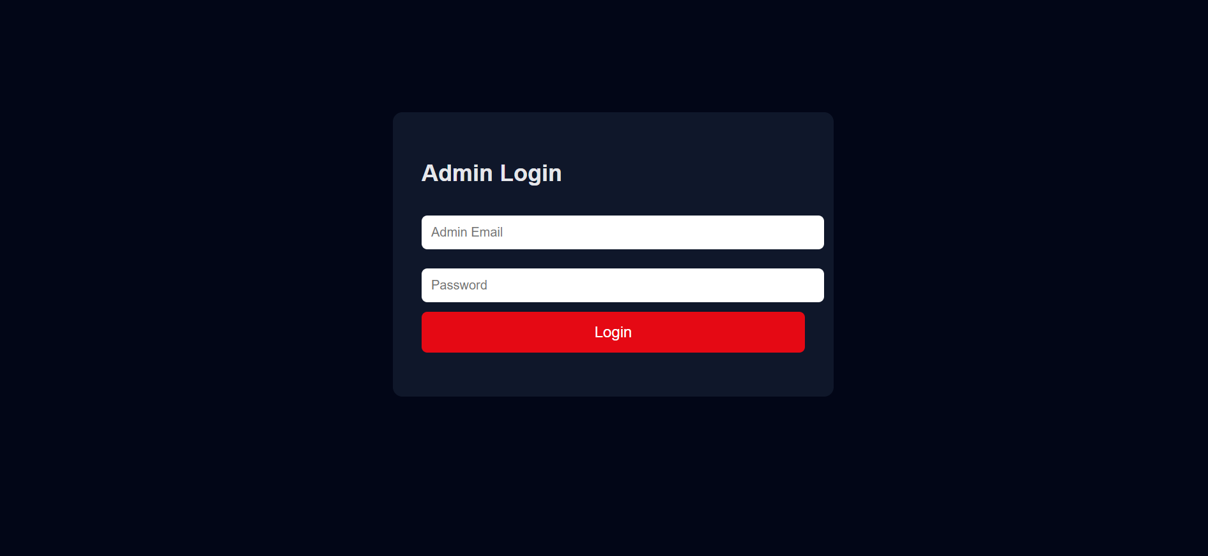
LOGIN PAGE (ADMIN):
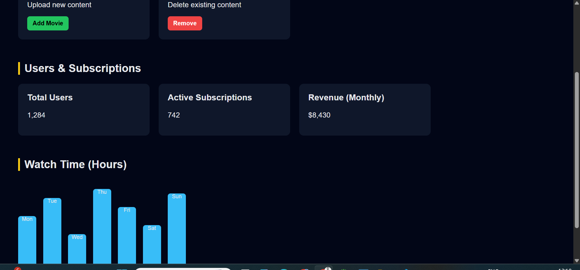
ADMIN DASHBOARD:

Drive link:
https://drive.google.com/file/d/1kTXl-gk7i0cBx7e3vCc4BiAVCg5i9Yju/view?usp=sharing

